**Step by step process for installing UiPath studio**

**Step 1: Open the link in browser-**<https://www.uipath.com/rpa/academic-alliance/academic-studio-download>.

**Step 2:Fill the contact details and choose the institution you belong to and then receive a link to download the software by email**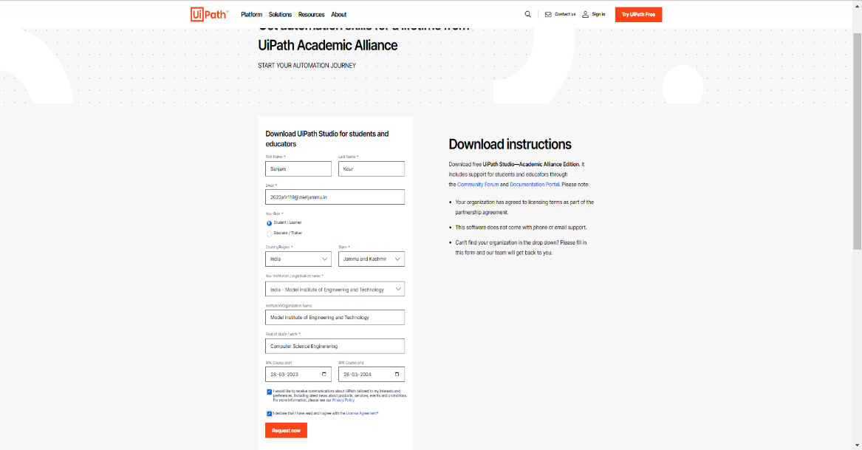

**Step 3: Click Request Academic Alliance Edition. Then, check your email.**

**The email contains the link to download the UiPathStudio.msi file along with dedicated license key. Click either the orange button or here.** 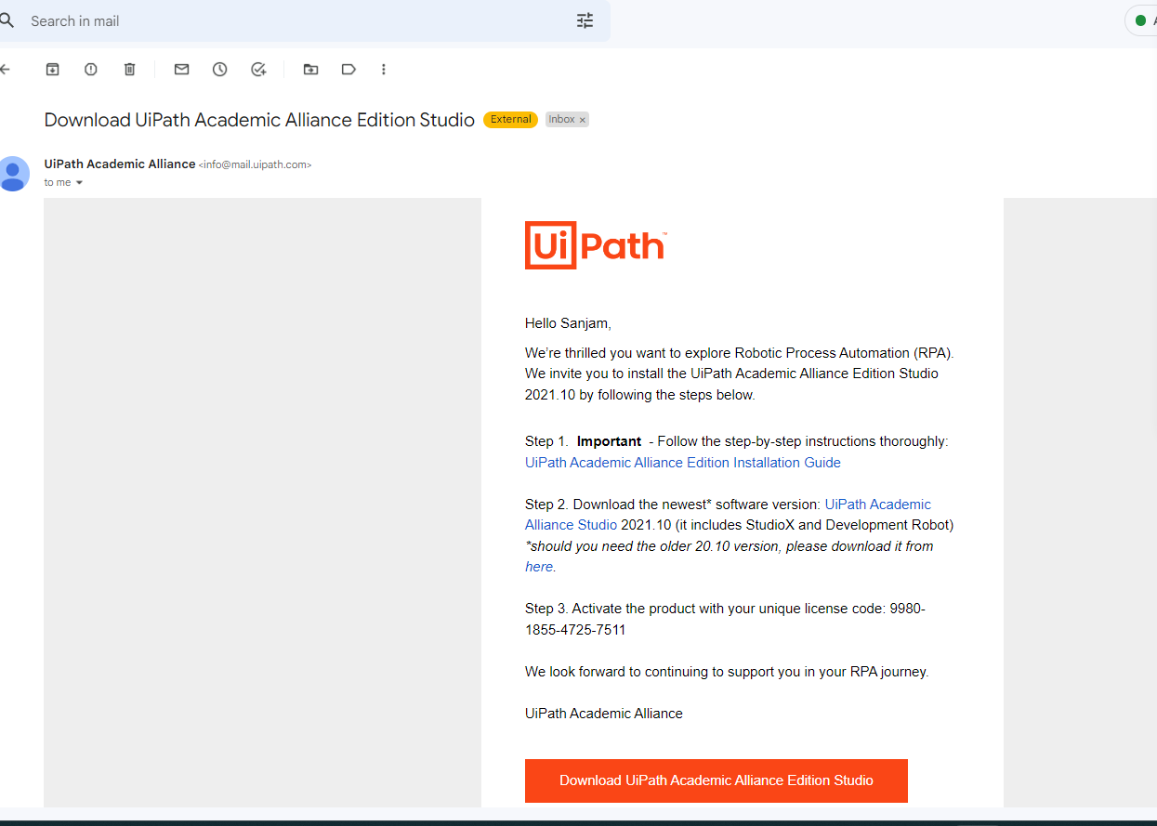

**Step 4: The file will begin downloading. Click to open the UiPath**

**Studio once it is downloaded.** 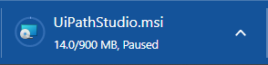

**Step 5: Accept the terms of the UiPath Studio License Agreement and click install.**

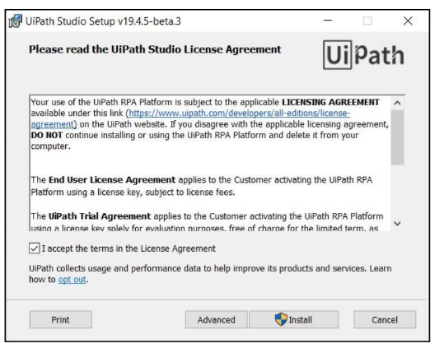

**Step 6: Make sure the Register as Windows Service option is deselected. To do this, click Register as Windows Service.**

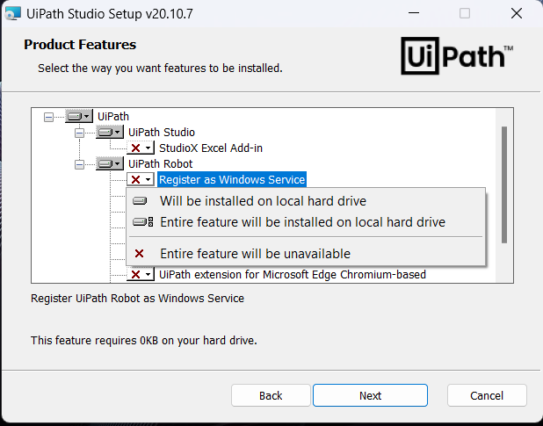

**Then, select Entire feature will be unavailable.**

**Step 7: Click Next to continue and then Install to begin the installation.**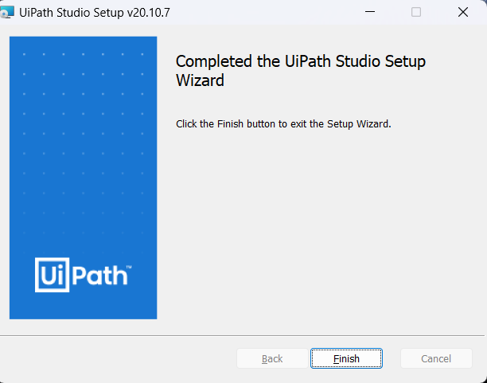

**Click Finish. If “Launch UiPath Studio” was checked, then UiPath Studio is launched.**

**Step 8: In the Welcome to UiPath Studio window, click Activate Stand-Alone License.**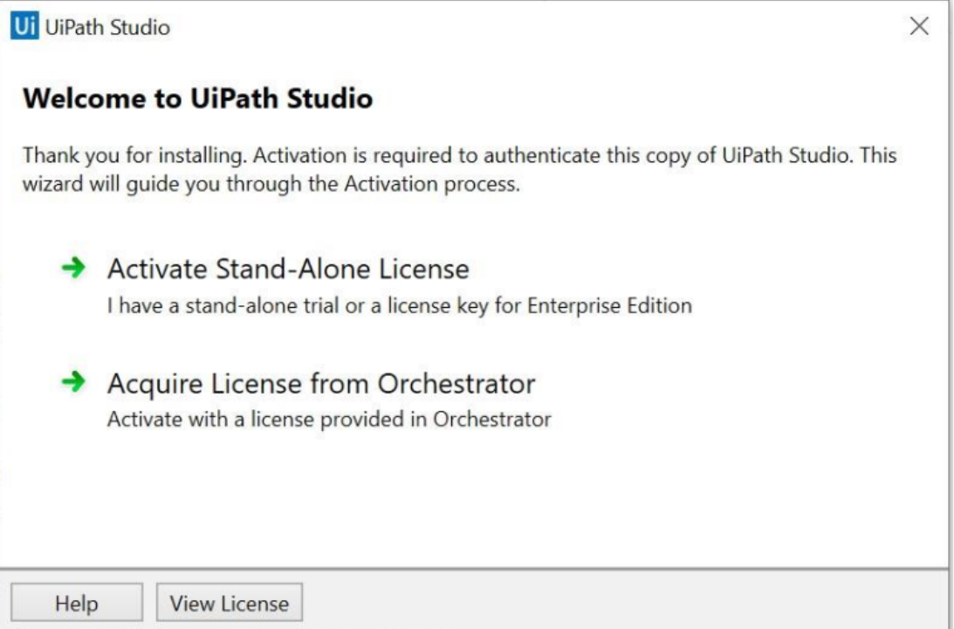

**Step 9: The UiPath Registration window is displayed.**

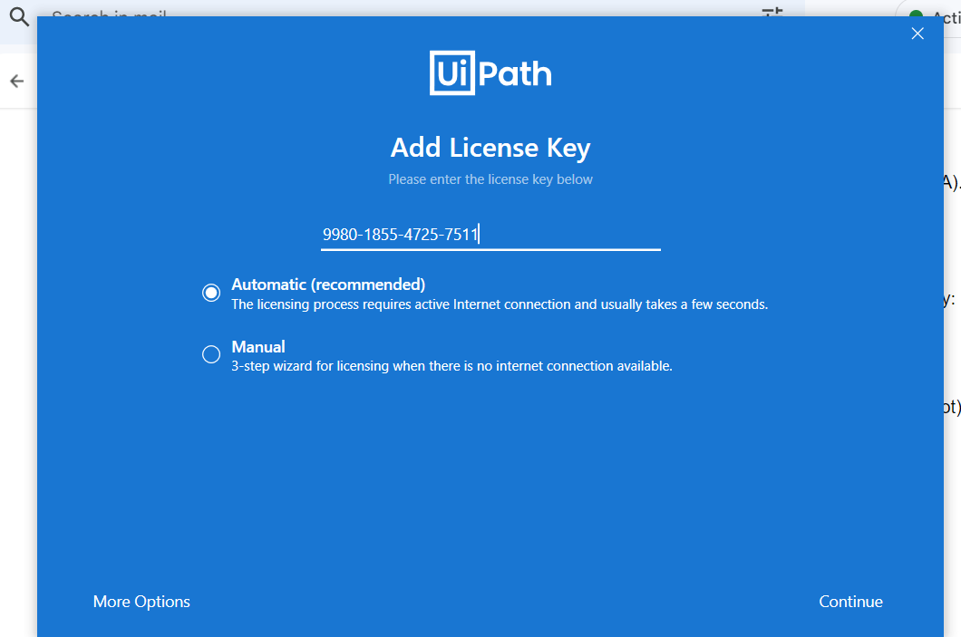

**a. Enter the License Key received by email.**

**b. Select Automatic activation.**

**c. Click Activate. Your UiPath license is now activated.**

**Now, you can start using UiPath software to create automation workflows.**

